SQL Tool Belt GUI

Managing servers and jobs can be, at times, require a complex set of tasks. The Tool Belt GUI is designed to simplify these tasks into a set of user screens.

# Servers

The first screen presented is the MAIN – Active Servers screen.

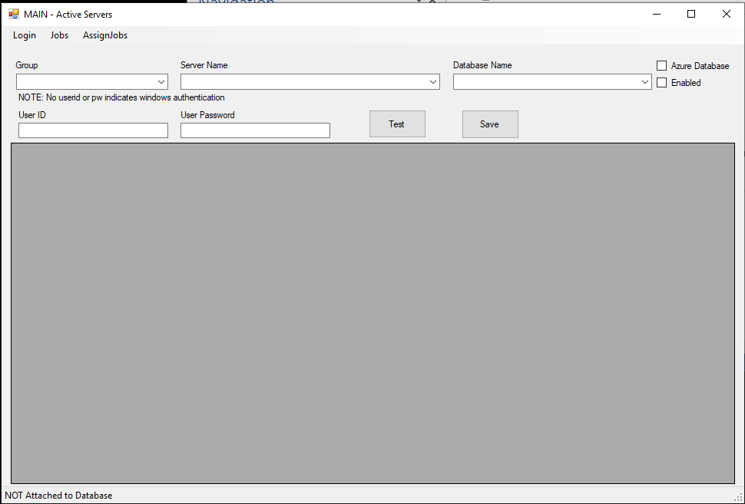

In the bottom left corner of this screen, it shows that we are not attached to the Master Repository at this time.

# Login

In the upper left hand corner, click “Login”.

You will see the login screen.

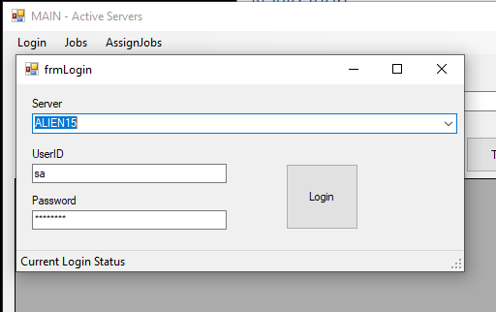

Fill in the correct information and press the Login button. If successful, you will be returned to the Main screen and a message at the bottom will state that the Server is connected.

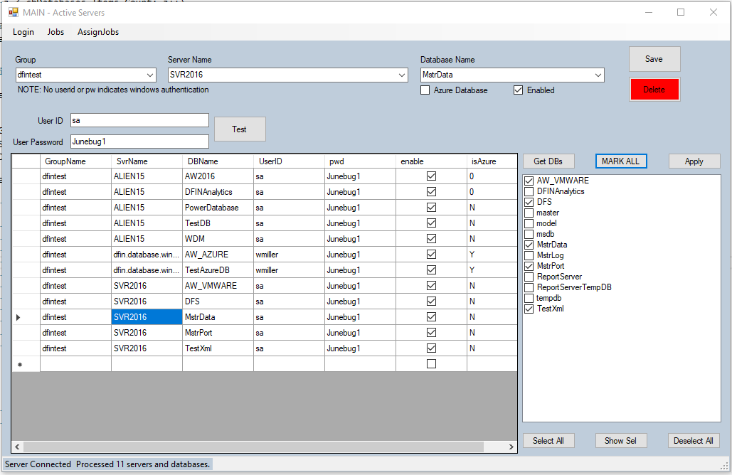

Test: Allows testing of the server connection before adding it to the list of Active Servers.

Save: Saves the specified server to the list of Active Servers.

Delete: Deletes the selected server from the list of Active Servers. No history is lost.

Get DBs: When a row is selected in the grid, that server and database are the currently selected (the targets). In order to see all the databases within that server, press the Get DBs button and the list will populate.

MARK ALL: When pressed, all databases that are currently selected on the target server will be checked.

Apply: When pressed, the selected databases will be added to the selected server for processing and any NOT selected will be removed. Use this with great care. Jobs can then be assigned to each database as needed. After completing an APPLY, review the added databases to make sure the parameters are set correctly.

Select All: In same rare cases, a database server can contain hundreds, even thousands of databases. In order to select all databases very quickly, press Select All.

Show Sel: No longer on screen – ignore in this document.

Deselect All: Does the same as the Select All, but in the reverse. It will deselect ALL databases within the list.

# Jobs

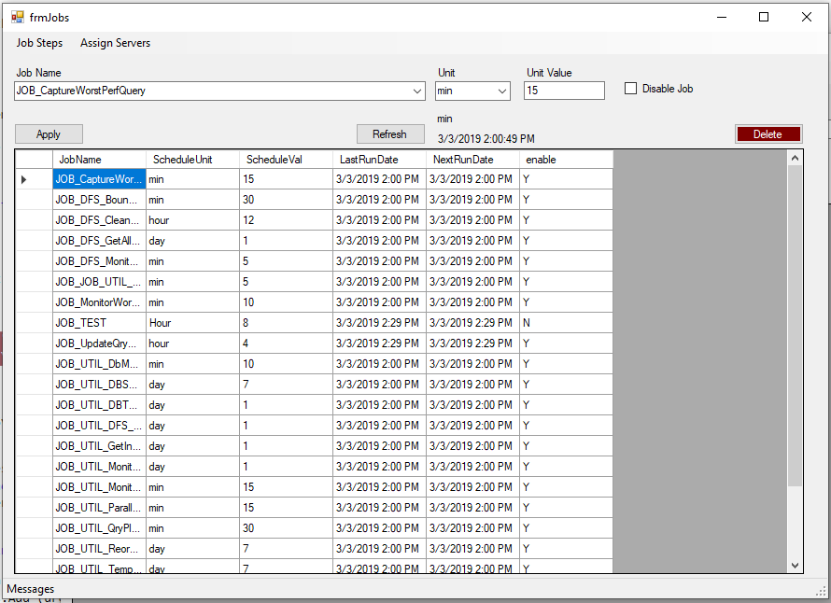

A job within the Tool Belt is represented by a name and one or more steps. The Job can be scheduled to run (executed through a PowerShell Interface) on a specified schedule. Select the Unit select the Unit Value. As shown above, the job is set to execute every 15 minutes.

Apply: Define a new job or modify an existing job and press Apply. The changes will be saved to the Master Database.

Refresh: After an update, to verify that the changes were applied, the Refresh can be selected and it will pull the all the Job data as it appears in the Master DB.

Delete: This deletes all occurrences of the selected job. Use care.

# Job Steps

In managing the steps within a job, the Job Step screen is the CRUD source.

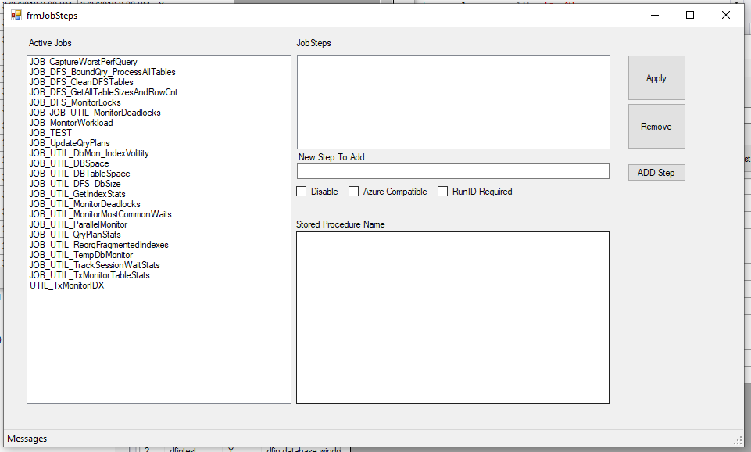

When first opened, all jobs are displayed.

Once a job is selected, the Steps within that job will appear and then, when a step is selected, the command (stored procedure name) will be displayed that is executed by the selected step within the selected job.

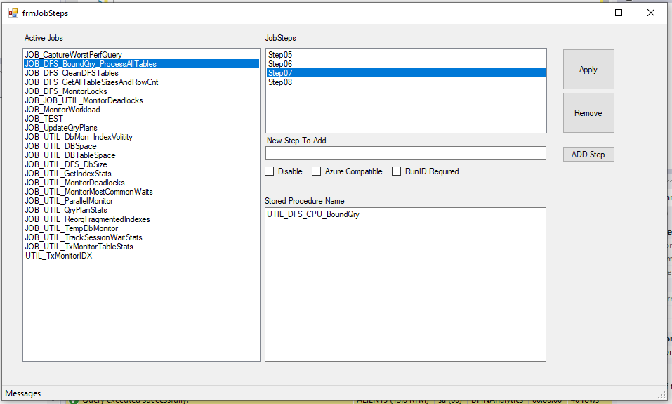

Apply: This button ONLY applies updates to selected steps. It will NOT insert a new step. This button allows all changes made within the Job Steps grid to be applied to the main database.

Remove: Deletes the selected step from the selected job.

Add Step: Inserts a new step to the selected job. A Step Name is required.

Disable: When checked, will disable the selected step within the selected job.

Azure Compatible: When selected, it specifies that this step within the selected job can run in an Azure environment.

RunID Required: In order to keep track of a cluster of diagnostics, a Run ID groups the findings (data) of a given diagnostics run (a job step) may require a Run ID. When checked, a Run ID is required for this step. The Run ID is a passed in parameter to the executing step’s named stored procedure.

# Assign Jobs / Assign Servers

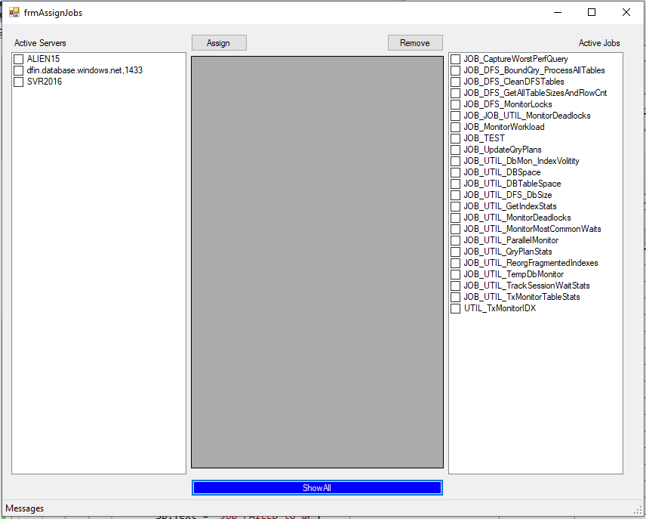

When first opened, no servers are selected and no jobs are selected. All servers and all jobs are shown. The Show All button on the bottom in blue will repopulate the Active Servers and Active Jobs with the current content of the Master DB and clear out the middle box until a selection is made.

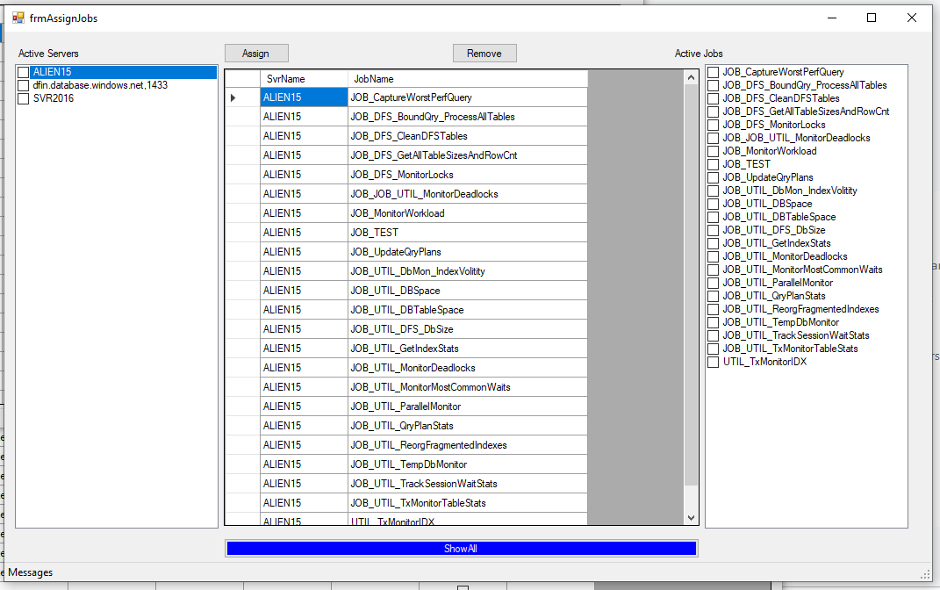

When a server is selected, all of the jobs associated/assigned to run on that server are display in the middle section of the screen.

Assign: To add jobs to a server, select the server’s check box, select the jobs check box that you wish to add to the server, and press the Assign button.

Remove: To remove a job from a server, select the job(s) from within the middle box and press the Remove button.

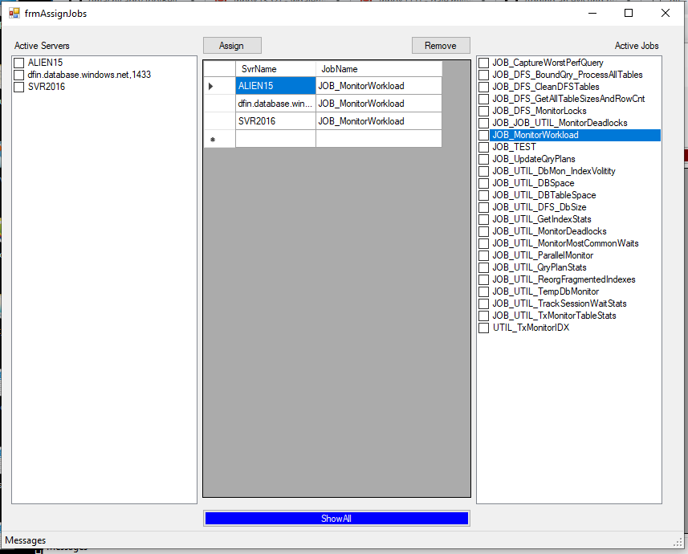

When a job is selected on from the Active Jobs list, the associated servers running that job are displayed.

Use the buttons as described above to manage these servers and jobs.